Citation: Lt Michael John Calverly ROBERTSON MC

Lieutenant Michael John Calverly ROBERTSON 2nd Green Jackets, The King's Royal Rifle Corps. On the 16th August 1965, Lieutenant Robertson was ordered to take his platoon and lay an ambush near the border in the Serian District of Sarawak on a likely enemy approach route. To achieve this, he had to negotiate some extremely difficult country with an ever-present risk of an enemy ambush en route. * He cited his ambush most skillfully and maintained it carefully concealed for three days before anything came into it. Then late on the third day a party of approximately 30 walked into the ambush area. Lieutenant Robertson waited until ten of the enemy were in the killing area and then personally sprung the ambush killing the centre man. Rapid fire was then opened by the rest of the ambush party at a range of about 70 yards and six of the enemy were seen to fall killed or seriously wounded. He then gave the order " watch and shoot". In the ensuing 10 to 15 minutes the enemy tried hard to retaliate and regain the initiative but every one of their efforts was thwarted by Lieutenant Robertson who was calmly controlling the battle with great skill. When the enemy brought down mortar fire close to his position, he called for artillery support which quickly silenced the mortaring, and when the enemy got first one and then two machine guns into action, he ordered his platoon sergeant to engage them with a rifle grenade. This action effectively silenced each gun in turn. When there were no more targets still visible to engage Lieutenant Robertson withdrew his ambush in good order to a pre-arranged rendezvous. During this withdrawal one rifleman was hit in the leg by a burst of fire and Lieutenant Robertson immediately went to his aid and helped to carry him back to the rendezvous where his wounds could be dressed before continuing the arduous journey back to the company base. Throughout this highly successful action Lieutenant Robertson was in complete control and by his calmness, courage and good tactical sense displayed leadership of a high order which set an inspiring example to his men. Lieutenant Michael John Calverly ROBERTSON Military Cross for this action.

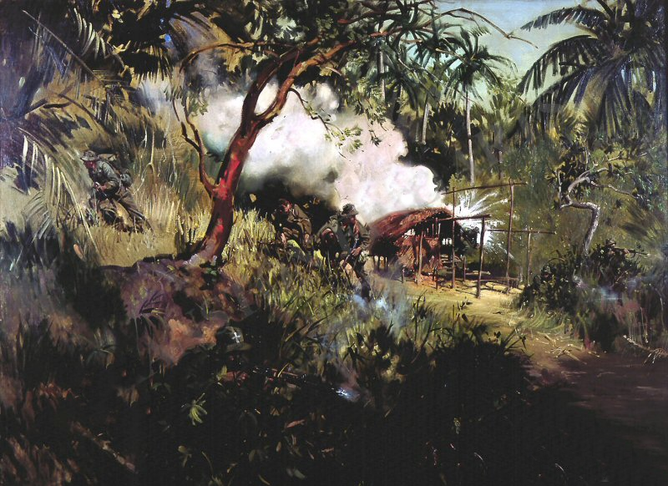
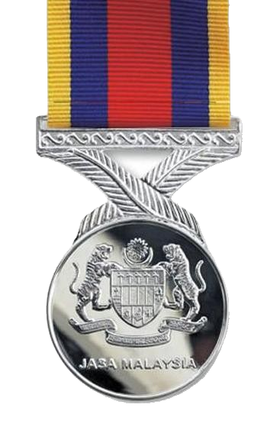
Painting depicts the injured Rifleman Martin being assisted,
following the ambush by Lt Robertson

